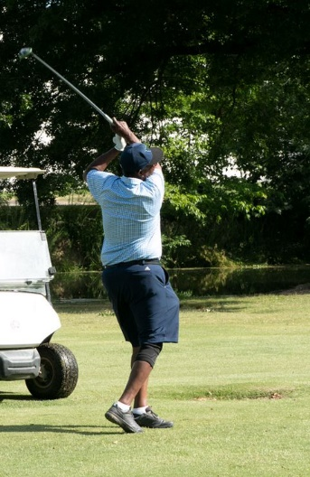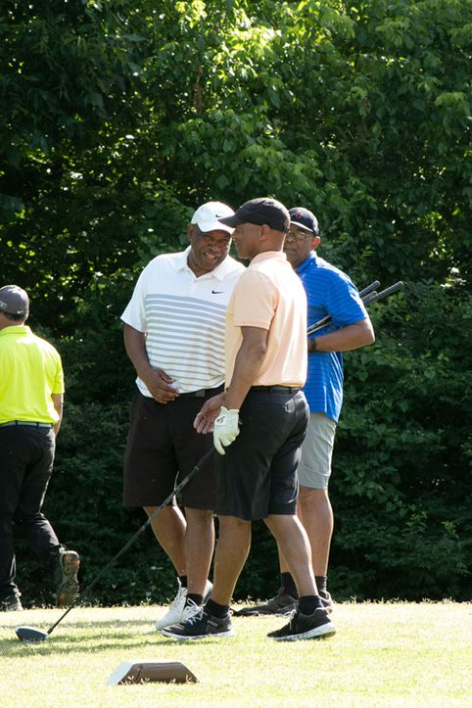
COMING SOON!
2022 Annual Golf Tournament – Players in ACTION!!
SAVE THE DATE
SAVE THE DATE
Saturday, June 3
Ted Rhodes Golf Course
Highlights
Fees
Registration

- 18 holes of golf
Individual $125 {on line fee $130}
Twosome $250 {on line fee $260}
Foursome $500 {on line fee $520}

- Player Gift Bags
Registration begins February 1 and ends May 1, 2023. You may register by mail or on line at www.gnabse.org No on-site registration!
- Grab & Go Breakfast
- Cocktails
- Lunch
- Awards & Prizes
- Silent Auction
TEAMS fill up quickly, so sign up early!
Download registration form at www.gnabse.org

