SAVE THE DATE
June 1, 2024 --- 8:00 AM
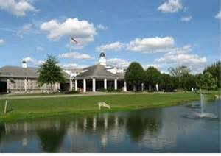
Proceeds will benefit the Gwendolyn V. Smith
Scholarship Fund.
Sign Up begins
March 1st
and ends
May 4th
Ted Rhodes Golf Course
1901 Ed Temple Blvd. Nashville, TN

Highlights
Download
Registration
Form
www.gnabse.org

From the home page, scroll down to the events calendar and click on registration form.

You may mail in your payment or sign up on line @
www.gnabse.org

REGULAR FEES
$125 Single
$500 Team

ON LINE FEES
$130 Single
$520 Team
- 18 Holes of Golf
- Grab & Go Breakfast
- Player Gift Bags
- Snacks & Refreshments
- Silent Auction
- Happy Hour
- Lunch
- Awards & Door Prizes

To sign up or for more information
Contact: Donnie Crenshaw @ (615) 604-6171 or Robert Blair @ (615) 397-2927

Mail payment to:
GNABSE, Attn: Golf Committee, PO Box 280233, Nashville, TN 37228

