***2025 ACT PREP SEMINAR***

With ZAPS Focused Test Prep from Doorway to College Foundation

Sponsored by

**Greater Nashville Alliance of Black School Educators**

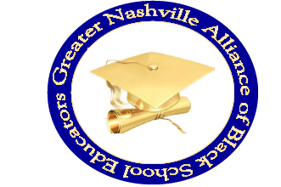 **P.O. Box 280233 - Nashville, TN 37228 (www.gnabse.org)**

**You may download an application to register at www.gnabse.org**

**We can help you maximize your score—and future success— with our *ZAPS®* Strategy Seminar**

**“Education is a Civil Right”**

Hosted at

**First Baptist Church Capitol Hill**

**625 Rosa Parks Blvd. - Nashville, TN 37203**





**February 22, 2025**

**8:00 AM – 2:00 PM**

**Cost $90.00**

***LIMITED SCHOLARSHIPS ARE AVAILABLE!***

***For more information or to register a student for the seminar, please contact Donnie Crenshaw at (615-604-6171) or*** [***dcrenshaw2014@gmail.com***](mailto:dcrenshaw2014@gmail.com)

***ALL APPLICATIONS MUST******BE RECEIVED BY******FEBRUARY 12, 2025!***

