2026 FALL ACT PREP SEMINAR

With ZAPS Focused Test Prep from Doorway to College Foundation

Sponsored by

Greater Nashville Alliance of Black School Educators
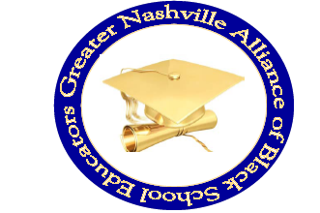
P.O. Box 280233 - Nashville, TN 37228 (www.gnabse.org)
We can help you maximize your score—and future success— with our ZAPS® Strategy Seminar!
Applications will be available on line, beginning September 1, at gnabse.org. From the home page, scroll down to the events calendar. You may download an application to register .

“Education is a Civil Right”

Hosted at
First Baptist Church Capitol Hill
900 Nelson Merry Street - Nashville, TN 37203

October 3, 2026

8:00 AM – 2:00 PM

NO COST FOR PARTICIPANTS!!
Although some colleges do not require test scores for admission, many colleges, even test-optional ones, still place a high value on ACT or SAT scores. A good ACT score enhances college admission chances, increases eligibility for scholarships and financial aid opportunities. Good ACT scores also reflect readiness for college-level courses.
---------------------------------------------------
For more information or to register a student for the seminar, please contact Donnie Crenshaw at (615-604-6171) or dcrenshaw2014@gmail.com
ALL APPLICATIONS MUST BE RECEIVED BY SEPTEMBER 19, 2026!

